

**HEALTH AND SAFETY POLICY STATEMENT**

**Health and Safety at Work Act 1974**

**General Company Policy for Health and Safety at Work including arrangements and organisation for carrying out that Policy.**

It is the Policy of Reynolds Group to take all possible steps to:

1. Provide and maintain systems of work that are, as far as reasonably practicable, safe and without risks to health
2. Provide training and supervision as is necessary to ensure the health and safety at work of staff, learners and visitors and delegates
3. Maintain, as far as reasonably practicable, in a condition that is safe and without risk to health, any place of work under our control, and the provision and maintenance that are safe and without risks
4. Provide and maintain a working environment that is, as far as is reasonably practicable, safe, without risks to health, and adequate as regards facilities and arrangements for welfare at work

**Young Workers**

It is the Reynolds Group Policy that we will adhere to the following guidelines for staff under 18 years of age:

1. The employee must be closely supervised at all times and under no circumstances be allowed to work alone
2. Duties that the young worker may participate in are limited and will avoid contact with any key hazardous areas
3. Upon commencement of the young worker, a specific risk assessment must be completed with the individual and a copy given to the learner / young worker to take home and make their ‘guardian’ aware – see young worker’s risk assessment

Reynolds Training Academy hereby informs staff, learners, visitors and delegates that they, each one, have a duty while at work/in training:

1. To take reasonable care for the health and safety of themselves and of other persons who may be affected by their acts or omissions at work/training
2. As regards any duty or requirement imposed on Reynolds Training Academy or any other person or under any of the relevant statutory provisions, to co-operate so far as is necessary to enable that duty or requirement to be performed or complied with

The Reynolds Group Senior Management Team, based at Reynolds Training Academy, Orchard House, Kent Road, Dartford, Kent, DA1 2AJ are responsible for fulfilling this Policy.

**Responsibilities in connection with Health, Safety and Welfare**

**Senior Managers:**

1. Shall provide adequate funds, materials and training to meet health and safety requirements
2. Shall make sure that Reynolds Training Academy Health and Safety Policy is understood at all levels and that responsibilities are accepted
3. Shall ensure that safety requirements are met when purchasing new equipment
4. To provide instruction and training for management, staff, learners and delegates both in general principles of accident prevention and in specific aspects of safety, to enable everyone to carry out their Health and Safety responsibilities effectively
5. To ensure that training in Health and Safety is included in induction training and incorporated into job/training instruction
6. To be available to any employee, learner and delegate for advice on safety matters
7. To organise investigation into any dangerous occurrences and recommend preventative action
8. To ensure that all buildings, plant, equipment meet all legal and company requirements
9. To ensure that all staff, learners and delegates understand the Health and Safety Policy
10. To stimulate interest and enthusiasm for safety and health awareness
11. To ensure that all legal requirements are met by all members of staff, learners and delegates

**Teachers / Tutors:**

1. To have a thorough knowledge of the Health and Safety Policy
2. To be aware of factors which give rise to accidents and to make continuous efforts to eliminate them
3. To ensure that any safe working practice introduced is adhered to
4. To ensure a high standard of housekeeping, cleanliness and hygiene in the studios, classrooms and all other areas used by them
5. If / when tutors take short courses for delegates/learners that are not full time they must make sure that the Health and Safety Policy is read out before courses begin and that learners / delegates are fully aware of exits, and fire evacuation meeting place
6. To make sure that the attendance register is checked off for all courses before the course begins and in the event of a building evacuation, all staff, learners and delegates are accounted for
7. No loose cables from any equipment must be visible on the floor of the training room at any time
8. Power supply must be out of the wall when the day is over (electrical music equipment, trainer’s computer, televisions etc)
9. There must be no obstacles on the floor of any room where training takes place at any time
10. Access to the Disabled toilet must be kept clear at all times

**Programme Managers / Senior Staff:**

1. To provide Attendance Registers to Tutors before the start of each term
2. To provide Safety Policy to Teachers to be read out to all delegates before start of courses
3. To ensure a high standard of hygiene in all areas, kitchenette, toilets and reception area
4. To organise dates for cleaners to clean offices and Global Hygiene to come to attend to toilets
5. To provide medical attention for sick or injured persons and inform management of any serious accident or hospitalisation
6. To record all accidents in the Accident Book
7. To record fire related incidents in the Fire Log Book
8. To organise the annual inspection of the Fire Extinguishers in all areas
9. To see that the First Aid box is fully stocked
10. To ensure the Disabled toilet is free from obstacles
11. To ensure that the connecting door is open (i.e. unlocked) during opening times
12. To ensure that air conditioning is working and maintained
13. To ensure that light bulbs are replaced when necessary
14. To ensure that hygiene in the kitchenette is maintained and that no dirty cups/saucers are left overnight
15. To organise bi-annual fire alarm maintenance checks, or to ensure that regular updates are received from landlord
16. To organise bi-annual burglar alarm checks, including external security lights

**All Company Employees:**

Have a legal responsibility under the Health and Safety at Work Act, Sections 7 and 8 of the act:

1. To take reasonable care for the health and safety of himself and of other people
2. No person shall intentionally or recklessly interfere with or misuse anything provided in the interests of safety, health or welfare

**Employees must:**

1. Be aware of the Health & Safety Policy
2. Report accidents to one of the managers or senior staff members
3. Understand Fire Procedures
4. Report possible problem areas to one of the managers or senior staff
5. Keep all public areas clean, hygienic, and free of obstacles
6. Look after themselves, colleagues, and delegates in the event of accidents/ evacuations

All staff have a responsibility to health and safety. This includes their own health and safety as well as that of the customers. Any health and safety issues must be immediately reported to the Principal.

**Risk Assessments**

Each site’s risk assessment is found in the Health & Safety folder behind reception.

The Risk Assessment covers:

* COSHH (Control of Substances Hazardous to Health)
* Fire risks
* Lifting
* Noise

The Risk Assessment is reviewed annually by the designated Health and Safety Lead and Area Manager for the Reynolds Group to ensure that it is up to date and relevant.

The Risk Assessment Probability Matrix is the key that is used to determine the risk and severity of any assessment.

**Risk Assessment Reports**

Fire - See health and safety folder in the General office.

<https://www.reynoldsgroup.co.uk/training/covid-19-risk-assessment/> - for reference 2020/21

For other emergencies, see General Operations Health & Safety Section.

**Fire Evacuation**

Hanging behind the reception is the Fire Evacuation Procedure list along with a luminous jacket. The list sets down the route that Fire Marshals take to evacuate the building in the quickest way possible.

When the alarm sounds the Fire Marshals return to reception, pick up the procedure form and put on the luminous jacket. The Fire Marshal looks at the Fire Panel to see where the fire is and proceeds to evacuate the Academy/College while the other Fire Marshals or Receptionist go to the location of the fire to see if it is a false alarm.

If it is a false alarm, the Fire Marshal/Receptionist must run back to reception, silence the alarm and stop the evacuation.

A Fire Alarm Report must be completed following the procedure on the Accident Report Form (see section 1.2.2) and placed in the designated health & safety leads tray. (All completed Fire Alarm Reports are kept in the folder in the general office.)

If the fire is genuine:

* If the fire is small and can be easily tackled, put it out. DO NOT ENDANGER YOURSELF. If you cannot tackle the fire phone the fire brigade and do the final check of the building before leaving yourself
* Do not re-enter the building yourself or allow anybody else to, until you have been told you can do so by the fire brigade or designated Health & Safety Lead.

The Fire Evacuation Log needs to be filled in after every false alarm, real evacuation or fire drill. Once completed it is placed in the designated health & safety lead's tray to be assessed and filed.

All fire extinguishers are on a service contract and are tested every 12 months. The date of the last test is written on each extinguisher and the certificates are kept in the Health & Safety folder behind reception (under Fire Extinguisher Service Records). It is the designated Health & Safety Lead’s

responsibility to ensure that the tests are up to date.

**Emergency Shut Off Procedures include:**

* Electricity
* Gas
* Water

**Robbery**

[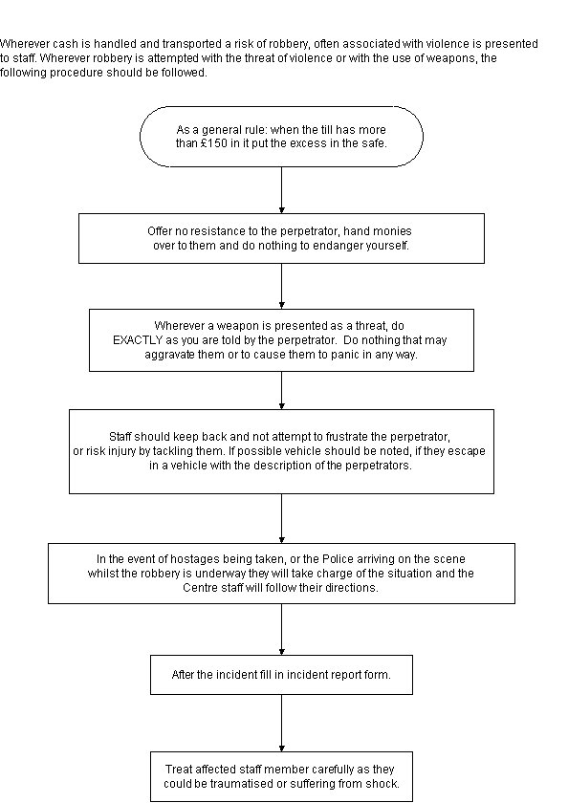](http://docs.reynoldsgroup.co.uk/index.php?title=File:Robbery2.JPG)

**Power Failure**

[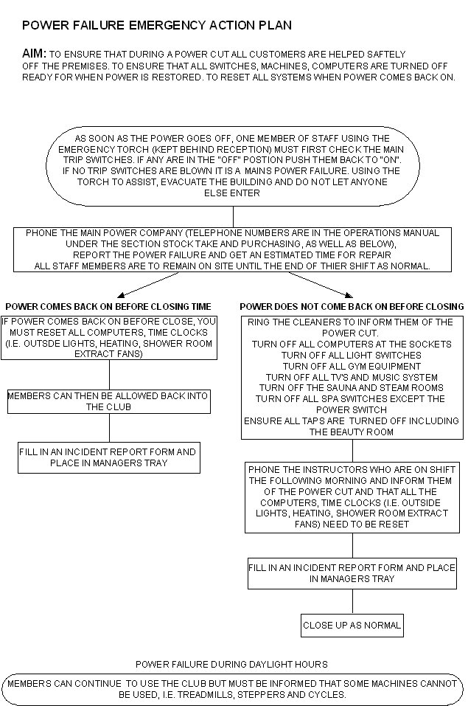](http://docs.reynoldsgroup.co.uk/index.php?title=File:Power_failure_2.JPG)

**Body Fluid Spillages**

[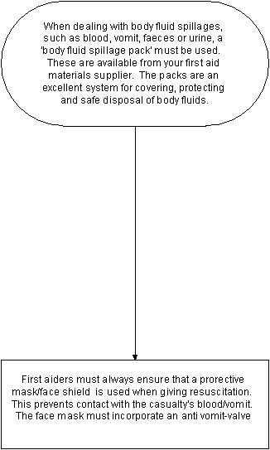](http://docs.reynoldsgroup.co.uk/index.php?title=File:Bodyfluid.JPG)

**First Aid**

It is required by law to have one First-Aider for every fifty employees.

A list of First Aiders is displayed at reception.

A photocopy of all staff certificates must be kept on each site in the health and safety folder.

**PAT Testing**

All portable electrical appliances must be tested once per year. The test reports are kept in the Pat Testing section in the Health & Safety folder at reception. Ensuring that PAT testing is carried out is the responsibility of the designated Health & Safety Lead.

**C.O.S.H.H (Chemicals and Other Substances Hazardous To Health)**

Located in the Health and Safety folder (kept in the general office) under the section "COSHH forms" you will find a list of approved chemicals that can be kept on site.

Behind this list can be found the COSHH sheets for each of these chemicals. These sheets list the chemical make up as well as how hazardous they are and what to do if they should come into contact with skin or eyes.

**Accident / Incident Reporting**

An Accident Report Form must be completed for every accident or incident, no matter how minor. It must be completed by the First Aider who dealt with the accident as soon as they have finished dealing with the casualty and / or the emergency services. Where possible the casualty should sign the accident report form where relevant.

If a visitor comes into Reynolds Training Academy and reports they had an accident the last time they were in, an Accident Report form must be completed. This can be completed by whoever is on reception. The date the accident happened and the date it was reported should be included on the form.

Completed forms must be placed in the designated Health & Safety Lead’s tray.

Use the flow chart below to correctly complete the Accident/Incident Reporting Procedure.

**Accident / Incident Reporting Procedure**

[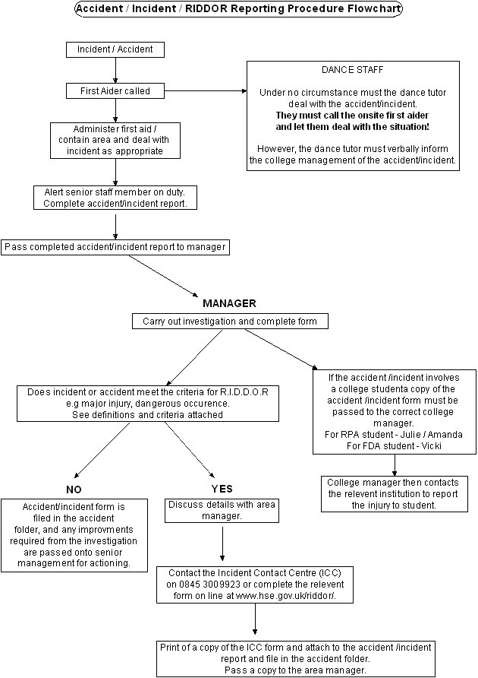](http://docs.reynoldsgroup.co.uk/index.php?title=File:Accident_flowchart_3a.JPG)

All accidents must be investigated, and measures put in place where necessary to ensure that similar accidents cannot re-occur. A report must be completed for the Directors.

**RIDDOR - What is Reportable**

What is reportable under RIDDOR? As an employer, a person who is self-employed, or someone in control of work premises, you have legal duties under RIDDOR that require you to report and record some work-related accidents by the quickest means possible.

**Reportable Deaths and Major Injuries**

**Deaths**

If there is an accident connected with work and your employee, or self-employed person working on the premises, or a member of the public is killed you must notify the enforcing authority without delay. You can either telephone the ICC on 0845 300 99 23 or complete the appropriate online form (F2508)[1].

**Major Injuries**

If there is an accident connected with work and your employee, or self-employed person working on the premises sustains a major injury, or a member of the public suffers an injury and is taken to hospital from the site of the accident, you must notify the enforcing authority without delay by telephoning the ICC or completing the appropriate online form (F2508)[2].

**Reportable Major Injuries**

* Fracture, other than to fingers, thumbs and toes
* Amputation
* Dislocation of the shoulder, hip, knee or spine
* Loss of sight (temporary or permanent)
* Chemical or hot metal burn to the eye or any penetrating injury to the eye
* Injury resulting from an electric shock or electrical burn leading to unconsciousness, or requiring resuscitation or admittance to hospital for more than 24 hours
* Any other injury: leading to hypothermia, heat-induced illness or unconsciousness; or requiring resuscitation; or requiring admittance to hospital for more than 24 hours
* Unconsciousness caused by asphyxia or exposure to harmful substance or biological agent
* Acute illness requiring medical treatment, or loss of consciousness arising from absorption of any substance by inhalation, ingestion or through the skin
* Acute illness requiring medical treatment where there is reason to believe that this resulted from exposure to a biological agent or its toxins or infected material

**Reportable over-three-day Injuries**

If there is an accident connected with work (including an act of physical violence) and your employee, or a self-employed person working on your premises, suffers an over-three-day injury you must report it to the enforcing authority within ten days.

An over-3-day injury is one which is not "major" but results in the injured person being away from work OR unable to do their full range of their normal duties for more than three days. You can notify the enforcing authority by telephoning the Incident Contact Centre on 0845 300 99 23 or completing the appropriate online form (F2508)[3].

**Reportable Disease**

If a doctor notifies you that your employee suffers from a reportable work-related disease, then you must report it to the enforcing authority. Reportable diseases include:

* Certain poisonings
* Some skin diseases such as occupational dermatitis, skin cancer, chrome ulcer, oil folliculitis/acne
* Lung diseases including: occupational asthma, farmer's lung, pneumoconiosis, asbestosis, mesothelioma
* Infections such as: leptospirosis; hepatitis; tuberculosis; anthrax; legionellosis and tetanus
* Other conditions such as: occupational cancer; certain musculoskeletal disorders
* decompression illness and hand-arm vibration syndrome

You can notify the enforcing authority by telephoning the Incident Contact Centre on 0845 300 99 23 or completing the appropriate online form (F2508A)[5]

**Reportable Dangerous Occurrences (near misses)**

If something happens which does not result in a reportable injury, but which clearly could have done, then it may be a dangerous occurrence which must be reported immediately. Just call the Incident Contact Centre on 0845 300 99 23 or complete the appropriate online form[6].

**Reportable Dangerous Occurrences:**

* Collapse, overturning or failure of load-bearing parts of lifts and lifting equipment
* Explosion, collapse or bursting of any closed vessel or associated pipework
* Failure of any freight container in any of its load-bearing parts
* Plant or equipment coming into contact with overhead power lines
* Electrical short circuit or overload causing fire or explosion
* Any unintentional explosion, misfire, failure of demolition to cause the intended collapse, projection of material beyond a site boundary, injury caused by an explosion; Accidental release of a biological agent likely to cause severe human illness
* Failure of industrial radiography or irradiation equipment to de-energise or return to its safe position after the intended exposure period
* Malfunction of breathing apparatus while in use or during testing immediately before use
* Failure or endangering of diving equipment, the trapping of a diver, an explosion near a diver, or an uncontrolled ascent
* Collapse or partial collapse of a scaffold over five metres high, or erected near water where there could be a risk of drowning after a fall
* Unintended collision of a train with any vehicle
* Dangerous occurrence at a well (other than a water well)
* Dangerous occurrence at a pipeline
* Failure of any load-bearing fairground equipment, or derailment or unintended collision of cars or trains
* A road tanker carrying a dangerous substance overturns, suffers serious damage, catches fire or the substance is released
* A dangerous substance being conveyed by road is involved in a fire or released

The following Dangerous Occurrences are reportable except in relation to offshore workplaces:

* unintended collapse of: any building or structure under construction, alteration or demolition where over five tonnes of material falls; a wall or floor in a place of work; any false-work
* Explosion or fire causing suspension of normal work for over 24 hours
* Sudden, uncontrolled release in a building of: 100 kg or more of flammable liquid; 10 kg of flammable liquid above its boiling point; 10 kg or more of flammable gas; or of 500 kg of these substances if the release is in the open air
* Accidental release of any substance which may damage health

Additional categories of dangerous occurrences apply to mines, quarries, relevant transport systems (railways etc) and offshore workplaces. Detailed information is provided in the relevant schedules to the regulations[7] and the Guide to RIDDOR[8]

RTA Health and Safety Policy – reviewed 11-8-2023 / 29-2-2024